Title: | Window Lifter  SW Component Design Specification

History
Issue status  (Index) | Maturity/Date  (draft/invalid/valid)  (dd-mmm-yyyy) | Author  Department | Check/Release  Department | Description
1.0 | Draft  26-June-2015 | Erick Salinas | AEP | Creation of the document.
2.0 | Draft  30-July-2015 | Erick Salinas | AEP | Traceability with requirements documents.
3.0 | Draft  2-July-2015 | Erick Salinas | AEP | Adding new requirement for correct operation. Described in final section.
4.0 | Draft  20-July-2015 | Erick Salinas | AEP | Include of Scheduler Service. Add if UML diagrams.
4.0 | Draft  20-July-2015 | Erick Salinas | AEP | Update UML diagrams with new State Machine for the Window Lifter

Table of Contents
1 Purpose 4
2 Definitions and abbreviations 4
3 Realization constraints and targets 4
4 Conceptual design 5
4.1 Input and Outputs 5
4.2 Uses Diagram 6
5 SW Component internal breakdown 7
5.1 Architecture Design 7
5.2 Class Diagram 8
5.3 Sequence Diagram 9
5.4 State Machine 10
5.5 Functions Overview 11
5.5.1 Void Debounse_PUSH_1ms(void) 11
5.5.2 Void WL_Func_2ms(void) 12
5.5.3 Function void Out_Leds(T_UBYTE* lub_level_ptr) 13
5.5.4 Void State_Machine_2ms(void) 13
5.5.5 Void Func_state_initial(void) 15
5.5.6 Void Func_state_up_inter(void) 16
5.5.7 Void Func_state_down_inter(void) 17
5.5.8 Void Func_state_up_manual(void); 18
5.5.9 Void Func_state_down_manual(void); 19
5.5.10 Void Func_state_up_auto(void); 20
5.5.11 Void Func_state_down_auto(void); 21
5.5.12 Void Func_state_antinpinch(void) 22
6 Comments and Disclaimer 23

Purpose

This document is designed to explain the use and implementation of the software created to control de window lifter module, and to have a better understanding of the code design.

Definitions and abbreviations
Definitions
PIT Periodic Interruption Timer
GPIO General Purpose Input Output
LED Light Emitting Diode
PLL Phase Lock Loop
MCU Microcontroller
MAL Microcontroller Abstraction Layer
HAL Hardware Abstraction Layer

References
N° | Document name | Reference
1 | Window lifter requirements | ⁽¹⁾
2 | Traceability matrix | ⁽²⁾
3 | Scheduler Specification | ⁽³⁾
4 | Scheduler Configuration | ⁽⁴⁾

Realization constraints and targets

The system consists in 10 LED’s representing the movement of a car window. All LED’s turn on represent the window is closed and every LED turning off represent one level of the window opening. It has two buttons to activate the rise and decline movements. It also detects pinch situations of the window simulated by an extra button. The system can detect invalid button press if they do not last more than 10ms. The movements have two different ways of operation depending on the duration of the button press, manually or automatically. If the button press last more than 500ms the system will increase one level, and if it last less than 500ms it will activate the automatic operation increasing the level until it reaches its maximum. Finally if the antipinch button is detected it will stop the rise movement and return to the open state. For more information on the system functionality check Window lifter requirements ⁽¹⁾ and Traceability matrix ⁽²⁾ description.

Conceptual design

Input and Outputs

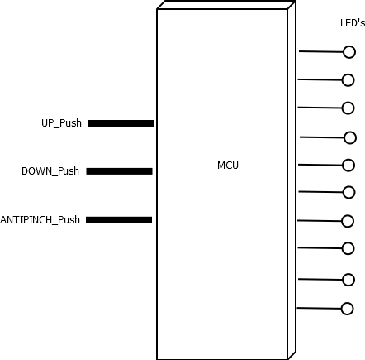

Figure 1 HW Inputs/Outputs

The system is handle by two control buttons that decide the direction of the movement indicated in the output LED’s. The antipinch is an external signal that indicate an obstruction in the window movement, and in this case is also simulated by a button. It is important to notice that even though the system is called Window Lifter, it is not designed to work with any motor actuator or window structure. It is design as an indicator for the real life movement. That is the reason in the diagram the 10 LED’s are shown as the real output of the system. Throughout the document the direction of the LED’s turning on is described as up and down, referenced to the window lifter representation. The three inputs have a debounce validation of 10ms to discard possible false readings as indicated in the requirements ⁽¹⁾.

Uses Diagram

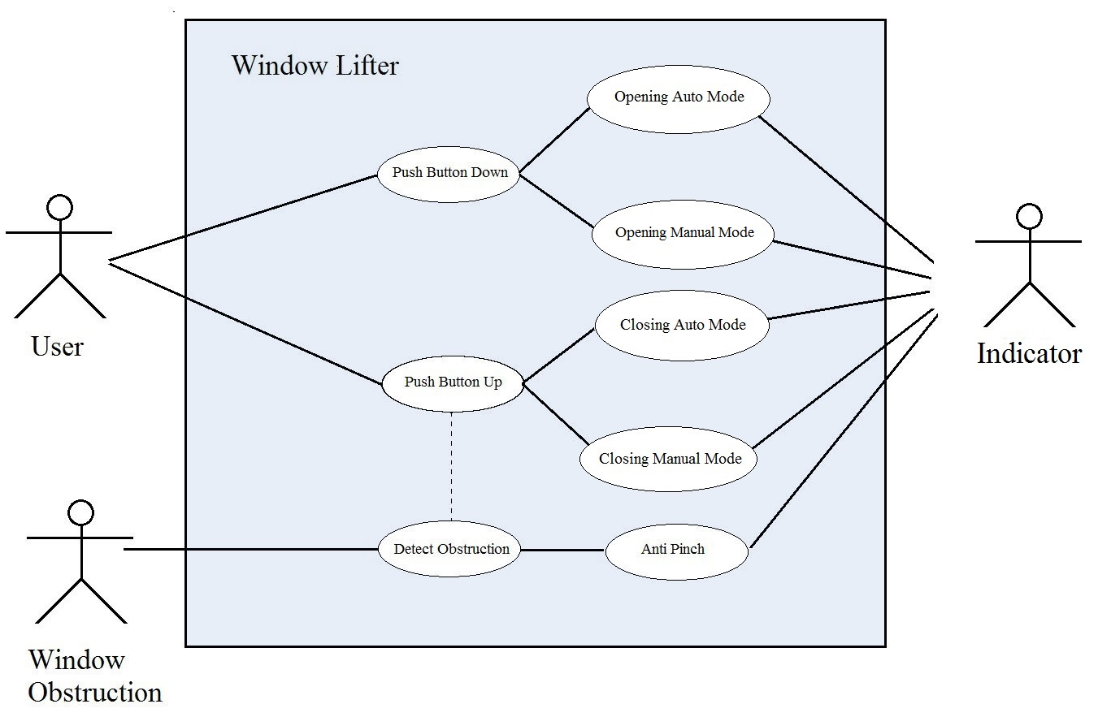

Figure 2 Uses Diagram

User: person who is going to interact with the system giving the order of up/down movements.
Window Obstruction: represent a possible obstacle for the window movement, it is shown as a different actor as the User because it can be caused by other possible source.
Push Button Down: Case when the down button action has been activated, still in the decision to activate the automatic or the manual mode.
Push Button UP: Case when the up button action has been activated, still in the decision to activate the automatic or the manual mode.
Opening Auto Mode: Increase the level of the window until it reaches it maximum.
Opening Manual Mode: Increase the level of the window one step while the button is press certain time. Stop when button is released.
Closing Auto Mode: Increase the level of the window until it reaches it minimum.
Closing Manual Mode: Decrease the level of the window one step while the button is press certain time. Stop when button is released.
Detect Obstruction: If the movement up is activated by the Push Button Up in any mode the antipinch is detecting any obstacle for the window movement.
Anti-Pinch: State when an Obstruction is detected and deactivate the buttons of directions. It will decrease the level to its minimum and wait for 5 seconds before any other button be read.
Indicator: Output actor of the system, represent by the 10 LED’s indicating the level of the system depending on the Use that is been set.

SW Component internal breakdown

Architecture Design

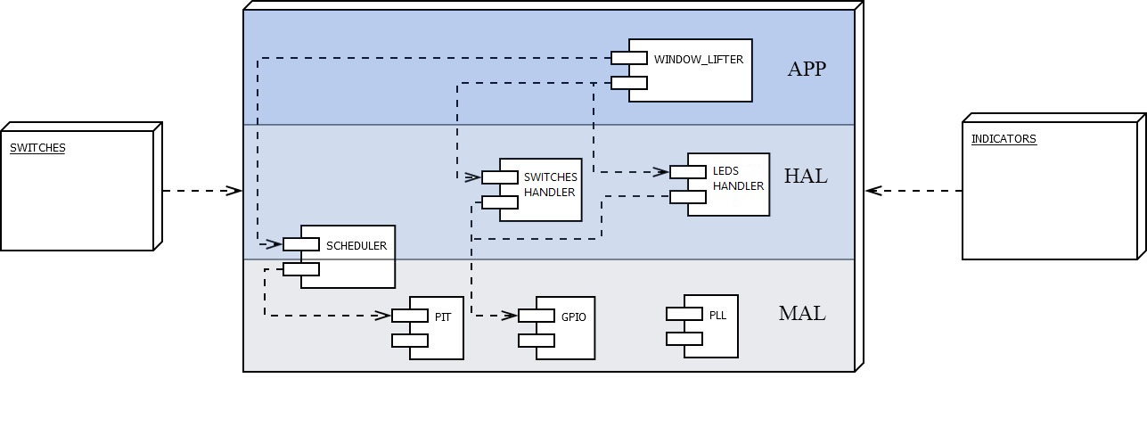

Figure 3 Architecture Diagram

PLL: Configures the running mode of the MCU and set the multiplication for the external clock.
GPIO: Contains the initialization and configurations for the input/outputs peripherals. Also the functions to control the output values when it is required.
PIT: Control the timer interruption configuration as well as its start and stop.
SCHEDULER: The system is mounted on a rate monotonic, no preemptive scheduler designed to work with a 500ms OStick. It is configured to work with one function of 1ms and another one of 2ms of period. The functions these tasks call are named after the period of their respective task. 1ms task call the function: Debounse_PUSH_1ms (). 2ms task call the function: WL_func_2ms (). For more information on the function of the scheduler go to the Scheduler Specification ⁽³⁾ and the Scheduler Configuration ⁽⁴⁾
SWITCHES_HANDLER: Driver of the specific input Switches Hardware. Initializes the ports needed trough the GPIO and have the functions needed to read properly the inputs.
LEDS_HANDLER: Driver of the specific output LED’s Hardware. Initializes the ports needed trough the GPIO and have the functions needed to write the proper outputs.
WINDOW_LIFTER: Contains the main application and control of the window lifter. It was design to work as a state machine following the logic shown in the next section.

Class Diagram

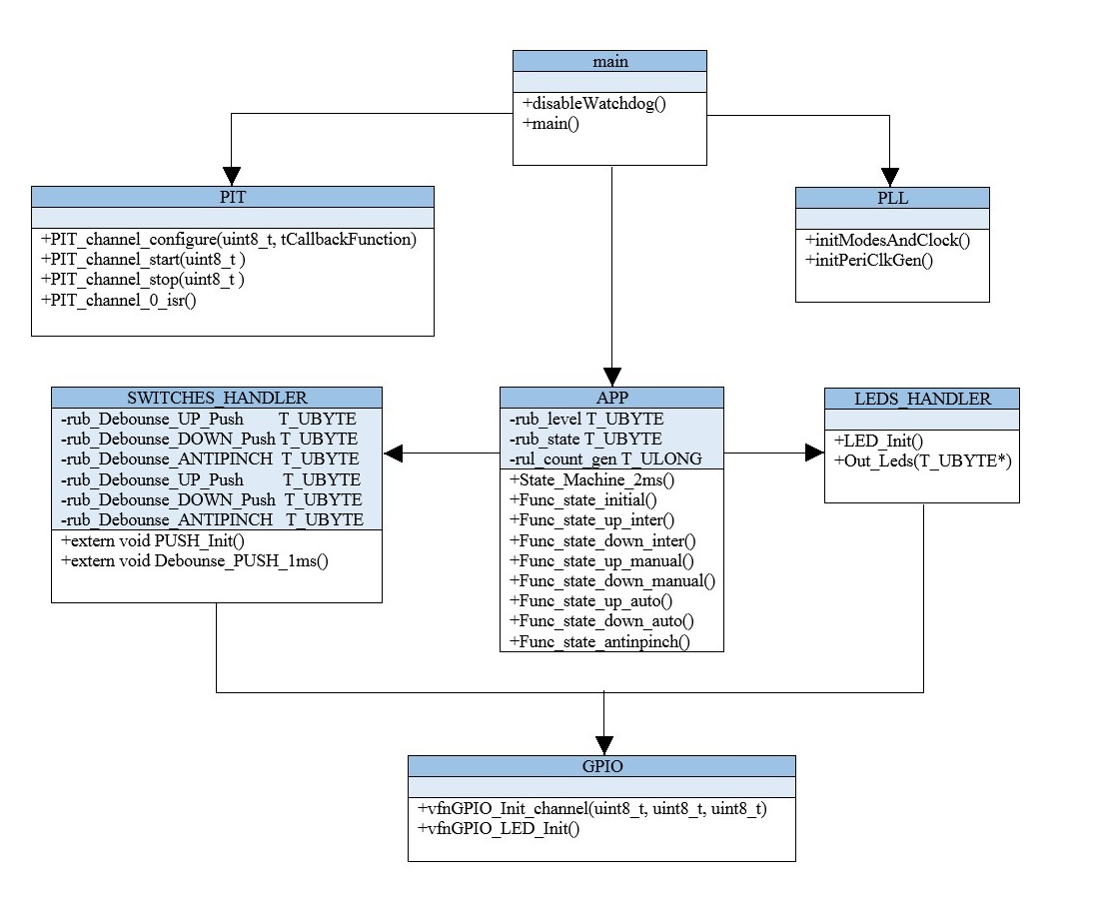
Figure 4 Class Diagram

Description of the module functions and the way they interact with each other. It is shown how the modules follow the architecture design. The direction of the arrows indicate how is the transference of information. Every module contains defines and functions necessary to the proper function of the specific task of the module, taking care of the portability of them. All the documentation about the Scheduler are described in the Scheduler Specification Document ⁽³⁾.

Sequence Diagram

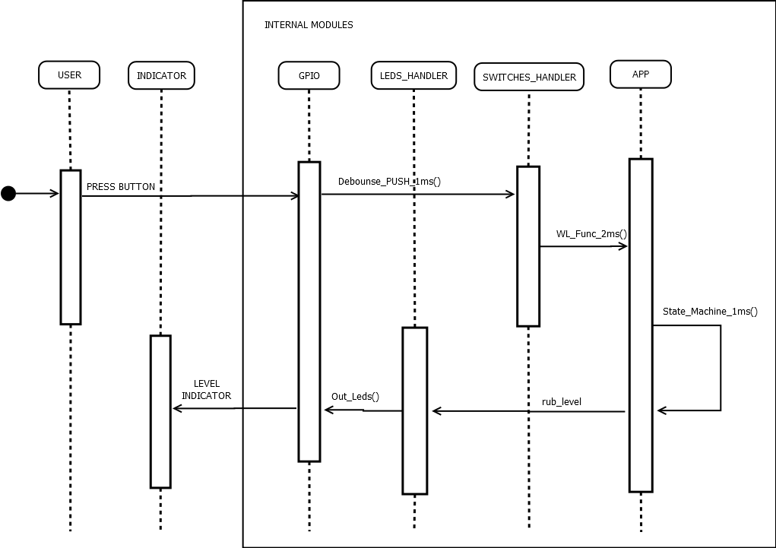

Figure 5 Sequential Diagram

In the sequence diagram it is shown the path of the instructions given by the user until it reaches back the indicator and can be read by the user again. We can see how the modules of the architecture design chronologically interact with each other and what the message send is. Notice that the Detection of an Obstruction is another signal that enters to the GPIO and follow the same path as the PRESS BUTTON.

PRESS BUTTON: Action by the user of pressing one of the directions buttons.
Debounce_PUSH_1ms (): Function that performs the debounce of the buttons sending validate signal to the SWITCHES_HANDLER.
WL_func_2ms (): Function insert on the 2ms task of the Scheduler that brings the actions from the SWITCHES_HANDLER to the APP Module.
State_Machine_1ms (): In the APP Module we have this function that runs the state machine of the system.
rub_level: Variable that contains the current level of the window send to the LEDS_HANDLER.
Out_Leds (): Function that translate the rub_level to specific actions to make in the GPIO and being translate to the real level shown in the INDICATOR.
LEVEL INDICATOR: The GPIO performs the actions set by Out_Leds (), and turns on the right amount of LED’s in the INDICATOR.

State Machine

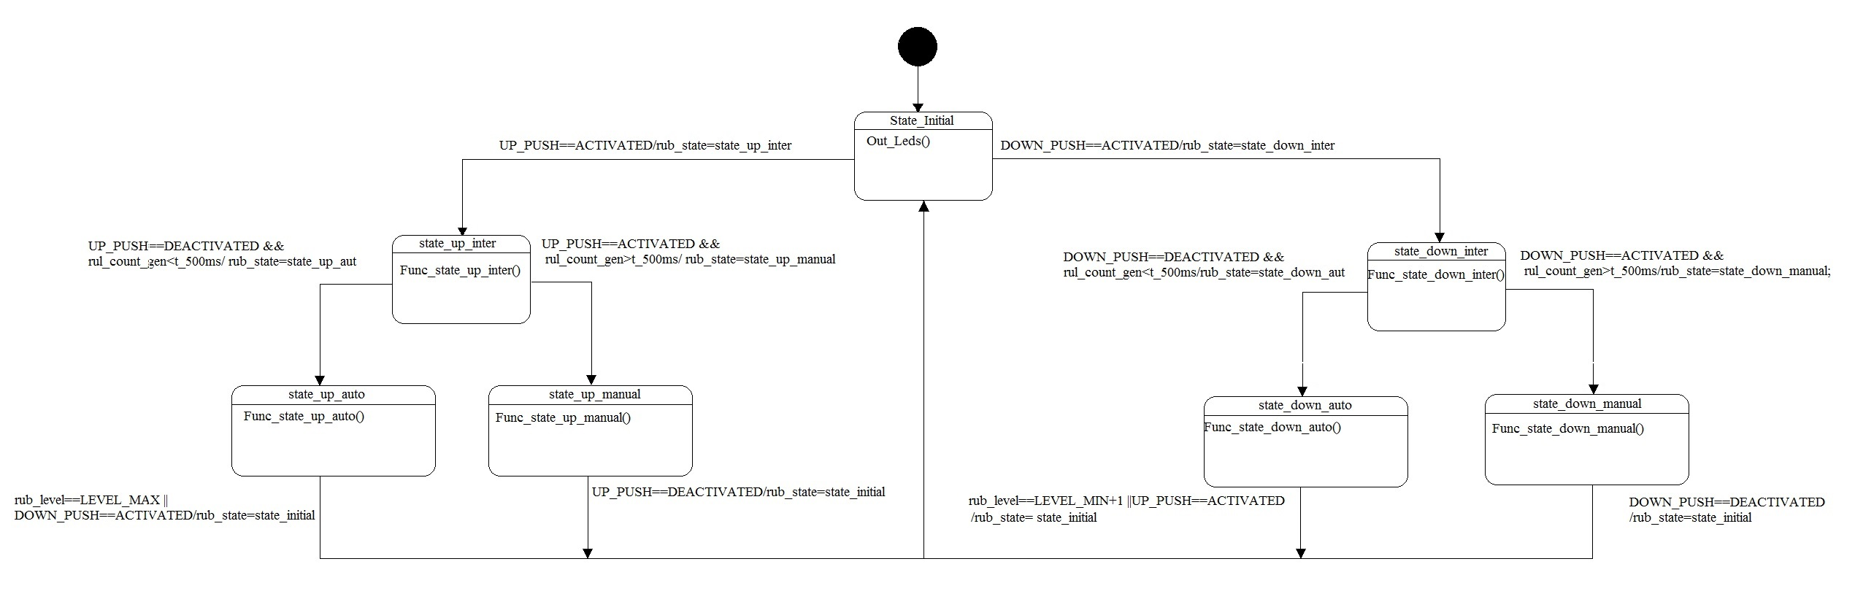
Figure 6 State Machine for Window Lifter Diagram

State_Initial: calls the Out_Leds() function to translate the level to the output. Waits for a debounce validate button press coming from the SWTICHES_HANDLER. Distributes to state_up_inter or state_down_inter depending on the case.

state_up_inter: Calculate the time that the action button is pressed. If the time pressed is more than 500ms it changes the state to state_up_manual if it is less to state_up_auto.

state_down_inter: Calculate the time that the action button is pressed. If the time pressed is more than 500ms it changes the state to state_down_manual if it is less to state_down_auto.

state_up_auto: Increase one level of the indicator every 400ms. The only state change condition is that the level reaches the maximum level of the indicator. In that case the machine goes to state_initial.

state_up_manual: Increase one level of the indicator every 400ms. The only state change condition is that the up button action is released. In that case the machine goes to state_initial.

state_down_auto: Decrease one level of the indicator every 400ms. The only state change condition is that the level reaches the minimum level of the indicator. In that case the machine goes to state_initial.

state_down_manual: Decrease one level of the indicator every 400ms. The only state change condition is that the down button action is released. In that case the machine goes to state_initial.

state_antipinch: Not specified in diagram cause is not reachable within the state machine function. The way to get into this state is if the antipinch signal is detected. That is checked during the WL_func_2ms() before the state_machine_2ms() is called. In case the signal is detected it will change the state of the machine to state_antipinch. From there, the system will follow the same behavior of state_down_auto decreasing one level every 400ms. After it reaches the minimum value the state will waits for 5 seconds before change to the state_initial.

Functions Overview

Void Debounse_PUSH_1ms(void)
Description | Reads the value of the Push buttons and validate the 10ms required to accept a valid press.
Parameter | Void
Return Value | Void
Precondition | This function is called by the 1ms task of the Scheduler.
Post condition | Validate the press of a button.
Requirements Included | R9, R10

*The BTTN prefix is substituted for each action button: UP, DOWN, ANTIPINCH. This means that there are one debounce validation for each button of the button.

Dynamic Behavior

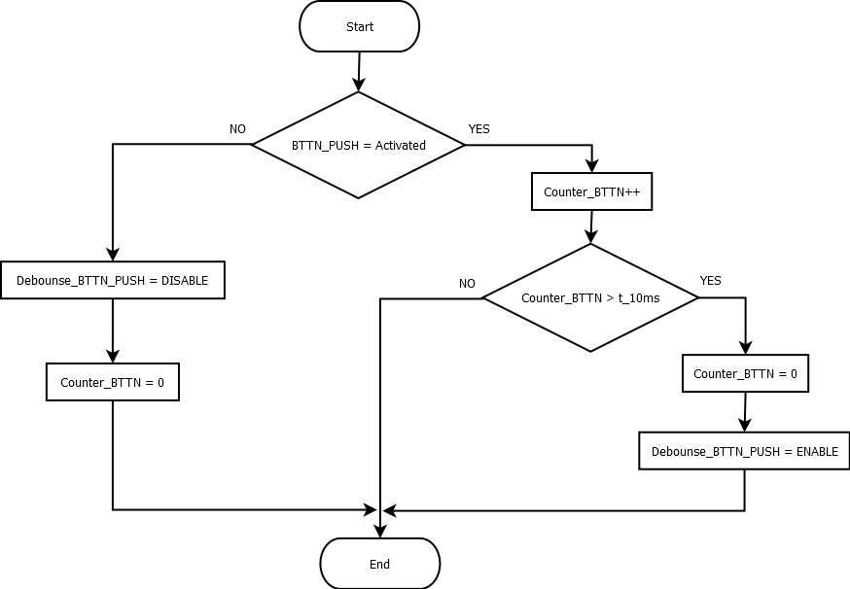

Figure 7 Debounse_PUSH_1ms() diagram

Void WL_Func_2ms(void)
Description | This function is dedicated to verify if the antipinch action is activated when the window is going up. Is executed before the State machine to give it a higher priority.
Parameter | Void
Return Value | Void
Precondition | This function is called by the 2ms task of the Scheduler.
Post condition | It calls the State_Machine_2ms() function.
Requirements Included | R14

Dynamic Behavior

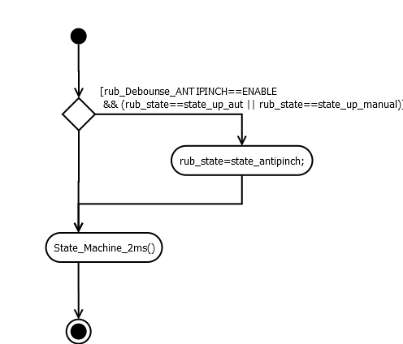

Figure 8 Debounse_PUSH_1ms() diagram

Function void Out_Leds(T_UBYTE* lub_level_ptr)
Description | This functions translate the variable level to the output LED’s. Receive the pointer of the variable level from APP.c.
Parameter | T_UBYTE* lub_level_ptr
Return Value | Void
Precondition | It is called after there’s been a change in the value of the variable level, to reflect the state of the system.
Requirements Included | R2, R4,

Dynamic Behavior

It consists on 10 “if” structure that activate the output pins for the LED’s depending on the value of the level variable.

Void State_Machine_2ms(void)

Description | This function contains the state machine that controls the different situations on the system. All states are reachable within the function, except for the state_antipinch that is activated from the WL_Func_2ms ().
Parameter | Void
Return Value | Void
Precondition | Is called from the WL_Func_2ms ().
Requirements Included | R11

Dynamic Behavior

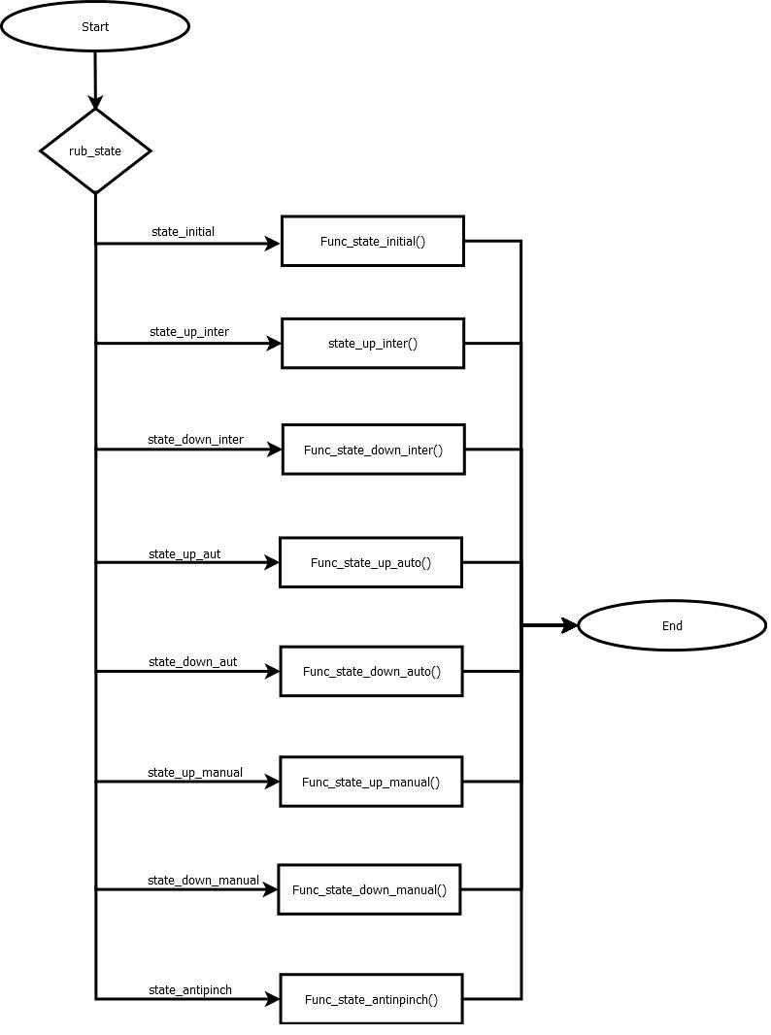

Figure 9 State_Machine_2ms () diagram

Void Func_state_initial(void)

Description | This state is waiting for a valid button action to decide to start an upwards movement or a downwards movement.
Parameter | void
Return Value | void
Precondition | The button action have been validated by the Debounce_PUSH_1ms() function.
Post Condition | The State machine can either go to State_up_inter or State_down_inter depending on the button action.
Requirements Included | R7, R11

Dynamic Behavior

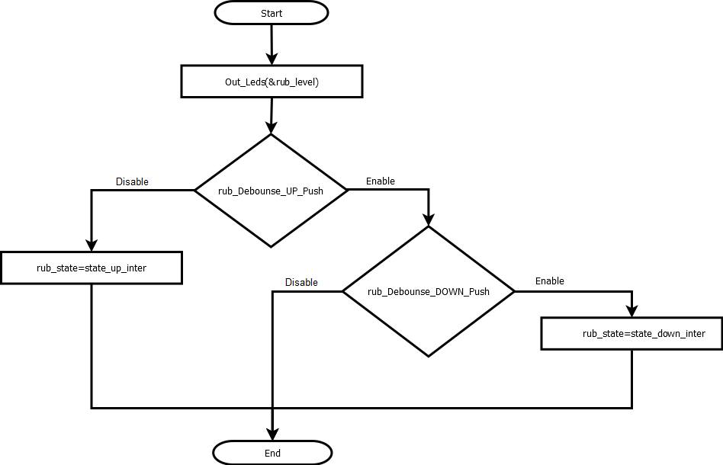

Figure 10 Func_state_initial() diagram

Void Func_state_up_inter(void)

Description | This function decides if the up action selected must be either automatic or manual mode depending on the pressing time.
Parameter | void
Return Value | void
Precondition | A valid up button action have been press.
Post condition | Depending on the pressing time the system will go in automatic or manual mode
Requirements | R11

Dynamic Behavior
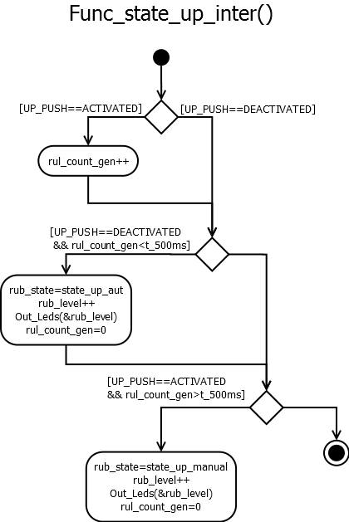

Figure 11 Func_state_up_inter () diagram

Void Func_state_down_inter(void)

Description | This function decides if the down action selected must be either automatic or manual mode depending on the pressing time.
Parameter | void
Return Value | void
Precondition | A valid down button action have been press.
Post condition | Depending on the pressing time the system will go in automatic or manual mode
Requirements | R11

Dynamic Behavior
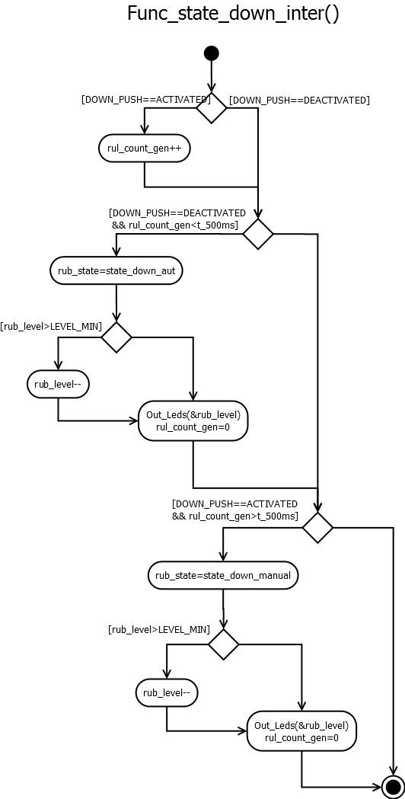

Figure 12 Func_state_down_inter() diagram

Void Func_state_up_manual(void);
Description | This function will increase one level every 400 ms in the manual mode until it reaches its maximum. It will go to the initial state when the button is released.
Parameter | void
Return Value | void
Precondition | A valid up button action have been press more than 500 ms
Requirements | R11

Dynamic Behavior
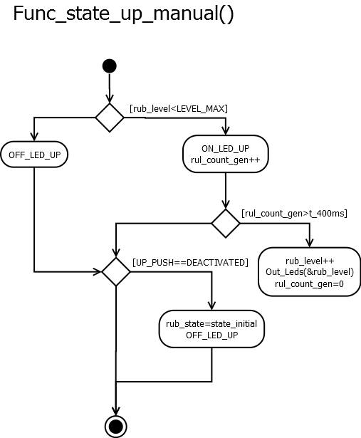

Figure 13 Func_state_up_manual () diagram

Void Func_state_down_manual(void);
Description | This function will decrease one level every 400 ms in the manual mode until it reaches its minimun. It will go to the initial state when the button is released.
Parameter | void
Return Value | void
Precondition | A valid down button action have been press more than 500 ms
Requirements | R11

Dynamic Behavior

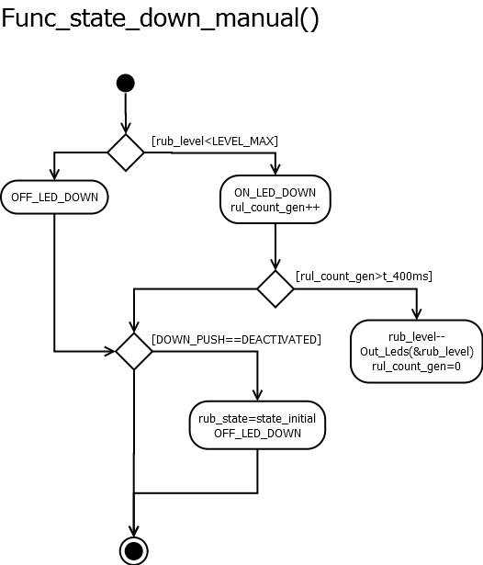

Figure 14 Func_state_down_manual () diagram

Void Func_state_up_auto(void);

Description | This function will increase one level every 400 ms in the automatic mode until it reaches its maximum. It will go to the initial state when the maximum level is reached
Parameter | void
Return Value | void
Precondition | A valid up button action have been press less than 500 ms
Requirements | R11

Dynamic Behavior

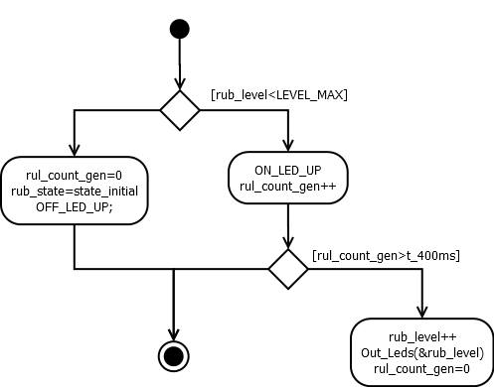

Figure 15 Func_state_up_auto () diagram

Void Func_state_down_auto(void);

Description | This function will decrease one level every 400 ms in the automatic mode until it reaches its minimum. It will go to the initial state when the minimum level is reached
Parameter | void
Return Value | void
Precondition | A valid down button action have been press less than 500 ms
Requirements | R11

Dynamic Behavior

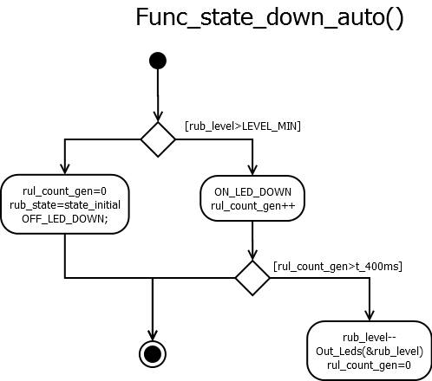

Figure 16 Func_state_down_auto () diagram

Void Func_state_antinpinch(void)

Description | This function works when the antipinch mode is detected. It will decrease the level in the same way of the automatic mode. But it will deactivate the other buttons for 5 second after it reaches the minimum level.
Parameter | void
Return Value | void
Precondition | The antipinch signal have been detected.
Requirements | R15, R16, R17, R18

Dynamic Behavior

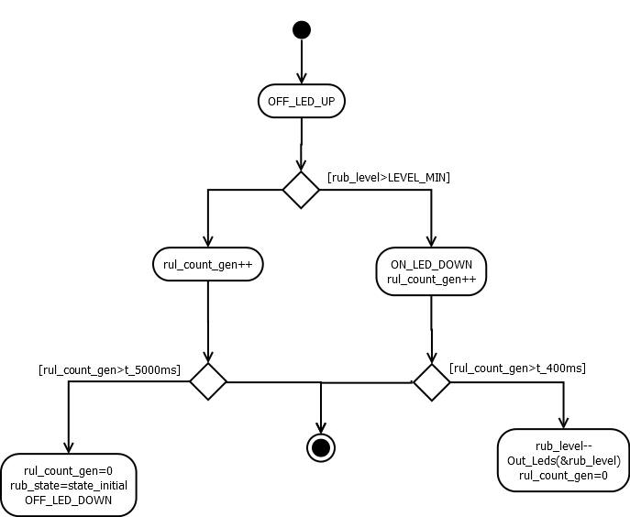

Figure 17 Func_state_antipinch () diagram

Comments and Disclaimer

As is mentioned in the Traceability matrix⁽²⁾ some of the client requirements were ambiguous, specifically R10, R14 and R15. For the R10 and R14 it is proposed to consider the antipinch signal source something different than a button. So this means that it can be activated at the same time as another button. So it is possible to interrupt the automatic and the manual up movement. This new consideration comes from the clarification of the R15. When it mentions that the antipinch must work when the movement is up, now we can consider that it also includes the manual mode and no only the automatic.

Finally in the 5 seconds of waiting after the antipinch operation the down LED remain on to indicate the system is not ready yet to continue.

